
ASSIGNMENT: 01
AROOBA_231678

VISUAL PROGRAMMING
AIR UNIVERSITY
BSCS_4B

1. Introduction
This project implements a simple Tic-Tac-Toe game using C# Windows Forms. It allows two players to play alternately, with an option to reset the game using a Restart button. Additionally, a single-player mode is included where the second player (O) is controlled by the computer, making random moves.

2. Features Implemented
- Two-Player Mode – Players take turns marking X and O on the board.
- Win Detection – The game detects a winner or a draw and displays a message.
- Restart Button – Resets the board to start a new game.
- Single-Player Mode (AI Opponent) – The computer makes random moves for Player O.

3. Code Explanation
- Player Moves
  - Players click on buttons to place X or O.
  - The HandleMove(Button btn) method updates the button and switches turns.
- Winning Conditions
  - The CheckWin() function checks rows, columns, and diagonals.
  - If a player wins, a message is displayed, and the game resets.
- Computer Move (AI)
  - The ComputerMove() method selects a random empty button and places an "O".
  - It ensures the AI doesn't overwrite existing moves.

4. Testing and Results
- The game successfully detects wins, losses, and draws.
- The AI makes random but valid moves.
- The Restart button resets the game correctly.

TIC TAC TOE CODE:
using System;
using System.Linq;
using System.Windows.Forms;

namespace TicTacToeWindows
{
public partial class Form1 : Form
{
private bool isPlayerX = true;
private int moves = 0;
private bool isSinglePlayer = false;

public Form1()
{
InitializeComponent();
}

private void Form1_Load(object sender, EventArgs e)
{
ResetGame();
}

private void button1_Click(object sender, EventArgs e) => HandleMove(button1);
private void button2_Click(object sender, EventArgs e) => HandleMove(button2);
private void button3_Click(object sender, EventArgs e) => HandleMove(button3);
private void button4_Click(object sender, EventArgs e) => HandleMove(button4);
private void button5_Click(object sender, EventArgs e) => HandleMove(button5);
private void button6_Click(object sender, EventArgs e) => HandleMove(button6);
private void button7_Click(object sender, EventArgs e) => HandleMove(button7);
private void button8_Click(object sender, EventArgs e) => HandleMove(button8);
private void button9_Click(object sender, EventArgs e) => HandleMove(button9);

private void btnRestart_Click(object sender, EventArgs e) // Restart Button
{
ResetGame();
}

private void btnSinglePlayer_Click(object sender, EventArgs e)
{
isSinglePlayer = !isSinglePlayer;
btnSinglePlayer.Text = isSinglePlayer ? "Single Player: ON" : "Single Player: OFF";
ResetGame();
}

private void HandleMove(Button btn)
{
if (btn.Text == "")
{
btn.Text = isPlayerX ? "X" : "O";
isPlayerX = !isPlayerX;
moves++;
CheckWin();

if (isSinglePlayer && !isPlayerX)
{
ComputerMove();
}
}
}

private void ComputerMove()
{
Random rand = new Random();
Button[] buttons = { button1, button2, button3, button4, button5, button6, button7, button8, button9 };

while (true)
{
int index = rand.Next(buttons.Length);
if (buttons[index].Text == "")
{
buttons[index].Text = "O";
isPlayerX = true;
moves++;
CheckWin();
break;
}
}
}

private void CheckWin()
{
string[,] board = {
{ button1.Text, button2.Text, button3.Text },
{ button4.Text, button5.Text, button6.Text },
{ button7.Text, button8.Text, button9.Text }
};

for (int i = 0; i < 3; i++)
{
// Check rows and columns
if (board[i, 0] != "" && board[i, 0] == board[i, 1] && board[i, 1] == board[i, 2])
{
ShowWinner(board[i, 0]);
return;
}

if (board[0, i] != "" && board[0, i] == board[1, i] && board[1, i] == board[2, i])
{
ShowWinner(board[0, i]);
return;
}
}

// Check diagonals
if (board[0, 0] != "" && board[0, 0] == board[1, 1] && board[1, 1] == board[2, 2])
{
ShowWinner(board[0, 0]);
return;
}

if (board[0, 2] != "" && board[0, 2] == board[1, 1] && board[1, 1] == board[2, 0])
{
ShowWinner(board[0, 2]);
return;
}

// Check for draw
if (moves == 9)
{
MessageBox.Show("It's a Draw!");
ResetGame();
}
}

private void ShowWinner(string winner)
{
MessageBox.Show(winner + " Wins!");
ResetGame();
}

private void ResetGame()
{
button1.Text = button2.Text = button3.Text = "";
button4.Text = button5.Text = button6.Text = "";
button7.Text = button8.Text = button9.Text = "";

isPlayerX = true;
moves = 0;
}
}
}

OUTPUT:
FORM VIEW:
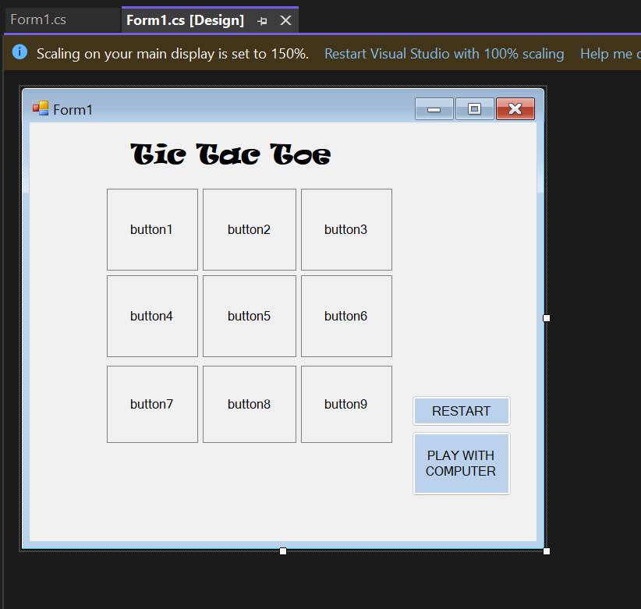
RUNNING VIEW:
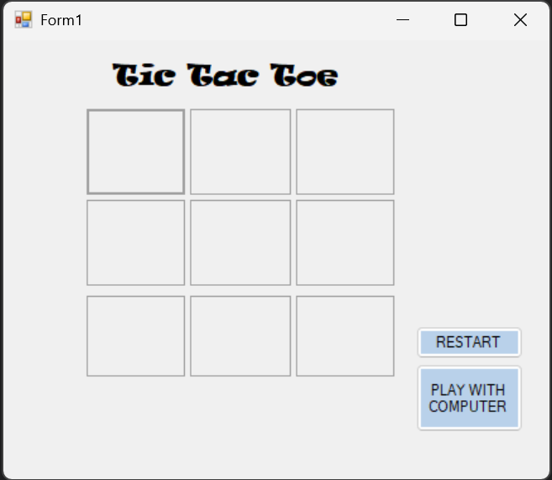
PLAYING VIEW:
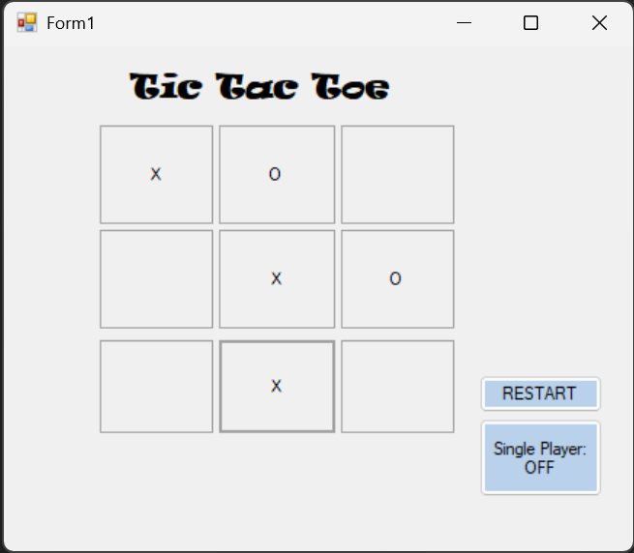

X WINS VIEW:
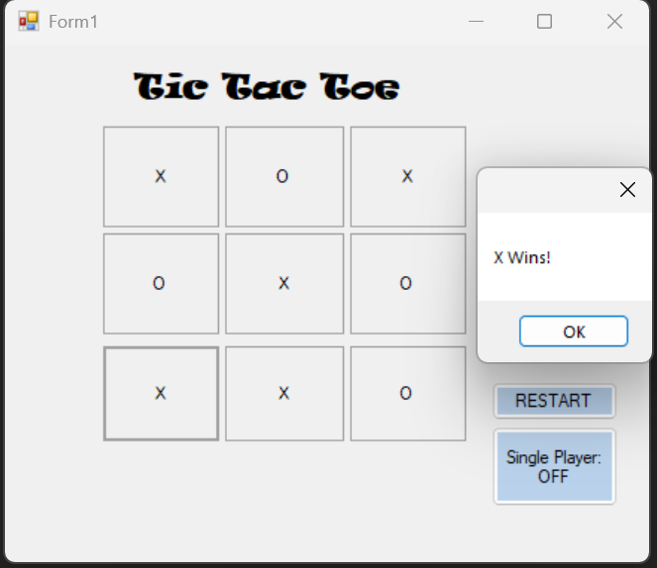
RESET VIEW:

COMPUTER PLAYING VIEW:
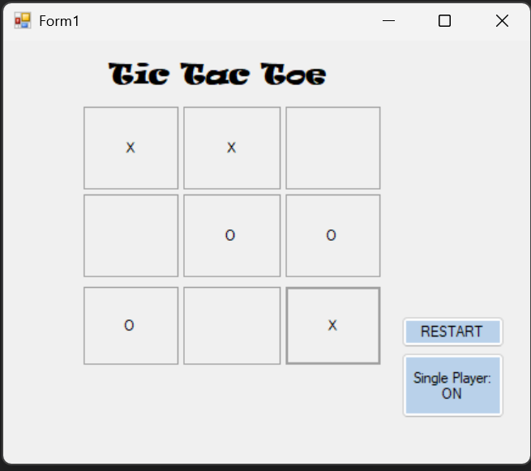
DRAW VIEW:
